Child Labor Statistics
Country-Level Insights into Child Labor Trends by Gender and Age Group
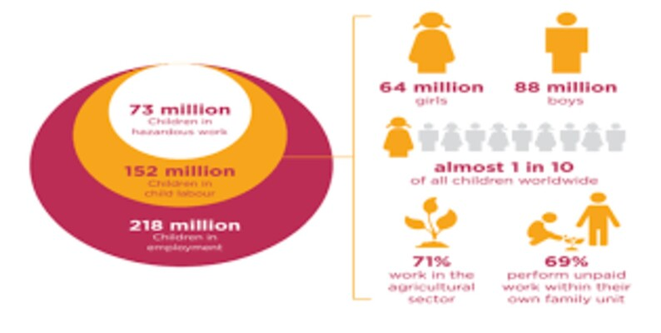
About Dataset
This dataset provides a structured overview of child labor prevalence across countries over time. It includes child labor rates (percentage) and estimated numbers of children involved (in millions), categorized by gender and age group. The dataset is suitable for policy analysis, academic research, socio-economic studies, and data visualization projects related to child welfare and labor economics.
Key KPIs (4–5)
KPI 1: Average Child Labor Rate (%)
Definition:
Average percentage of children involved in labor across all countries.
Why it matters:
Shows the overall global severity of child labor.
Insight use:
Track whether child labor is improving or worsening over time.
KPI 2: Total Estimated Children in Labor (Millions)
Definition:
Sum of Estimated_Children_Millions.
Why it matters:
Represents the actual scale of the problem in population terms.
Insight use:
Helps policymakers prioritize funding and intervention.
KPI 3: Country with Highest Child Labor Rate
Definition:
Country with the maximum Child_Labor_Rate_Percent.
Why it matters:
Identifies high-risk countries requiring urgent attention.
KPI 4: Region-wise Average Child Labor Rate
Definition:
Average child labor rate grouped by Region.
Why it matters:
Highlights which regions are most affected.
KPI 5: Gender-wise Child Labor Participation
Definition:
Comparison of child labor rate or estimated children by Gender.
Why it matters:
Reveals whether boys or girls are more affected.
📈 Business Analysis Questions (Simple → Moderate)
1. Which region has the highest average child labor rate?
Purpose:
To identify geographically vulnerable regions.
Recommended chart:
Bar chart (Region vs Avg Child Labor Rate)
2. Which countries contribute the most to child labor globally?
Purpose:
To understand where the highest number of working children live.
Recommended chart:
Top 10 countries – Bar or Tree Map
3. Is child labor more prevalent among boys or girls?
Purpose:
To identify gender disparity in child labor.
Recommended chart:
Clustered column or pie chart (Gender-wise)
4. How has child labor changed over different years?
Purpose:
To track progress or deterioration over time.
Recommended chart:
Line chart (Year vs Avg Child Labor Rate)

5. Which age group is most affected by child labor?
Purpose:
To target age-specific policies and education programs.
Recommended chart:
Bar chart (Age Group vs Estimated Children)

6. Are some regions improving faster than others over time?
Purpose:
To compare effectiveness of regional policies.
Recommended chart:
Line chart with Region as legend

